**1.Is the <!DOCTYPE html> tag considered as a HTML tag?**

No, the <!DOCTYPE html> declaration is not an HTML tag.

There are many type of HTML, such as, HTML 4.01 Strict, HTML 4.01 Transitional, HTML 4.01 Frameset, XHTML 1.0 Strict, XHTML 1.0 Transitional, XHTML 1.0 Frameset, XHTML 1.1 etc. So, <!DOCTYPE html> is used to instruct the web browser about the HTML page.

**2.What is the use of a span tag? Explain with example**.

The span tag is used for following things:

* For adding color on text
* To add background on text
* Highlight any color text

Example:

<span style=”color:#ffffff;”>

In this page we use span.

</span>

**3.What is Cell Spacing and Cell Padding**?

Cell Spacing is referred to as the space or gap between the two cells of the same table. Whereas, Cell Padding is referred to as the gap or space between the content of the cell and cell wall or cell border.

Example:

<table border cellspacing=3>

<table border cellpadding=3>

<table border cellspacing=3 cellpadding=3>

**4.What is the alt attribute in HTML**?

The alt attribute is used for displaying a text in place of an image whenever the image cannot be loaded due to any technical issue.

<!DOCTYPE html>

<html>

<body>

<h2>HTML Alt Example</h2>

<img src=”tulip.jpeg” alt=”Tulip Garden” />

</body>

</html>

**5.How do you add CSS styling in HTML?**

There are three ways to include the CSS with HTML:

**Inline CSS**: It is used when less amount of styling is needed or in cases where only a single element has to be styled. To use inline styles add the style attribute in the relevant tag.

**External Style Sheet**: This is used when the style is applied to many elements or HTML pages. Each page must link to the style sheet using the <link> tag:

<head>

<link rel=”stylesheet” type=”text/css” href=”mystyle.css”/>

</head>

**Internal Style Sheet**: It is used when a single HTML document has a unique style and several elements need to be styled to follow the format. Internal styles sheet is added in the head section of an HTML page, by using the <style> tag:

<head>

<style type=”text/css”>

Hr {

Color: sienna;

}

P {

Margin-left: 20px;

}

Body {

Background-image: url(“images/back40.gif”);

}

</style>

</head>

**6.Which HTML tags are used while displaying the data in the tabular form?**

The following HTML tags are used to display the data in the tabular form:

1. <table> Defines a table.
2. <tr> Defines a row in a table.
3. <th> It defines a header cell in a table.
4. <td> Defines a cell in a table.
5. <caption> This tag defines the table caption.
6. <colgroup> This tag specifies a group of one or more columns in a table for formatting.
7. <col> It is used with <colgroup> element to specify column properties for each column.
8. <tbody> This tag groups the body content in a table.
9. thead> It groups the header content in a table.
10. <tfooter> It groups the footer content in a table.

**7.What is a marquee?**

Marquee tag is a non-standard HTML element that causes text to scroll up, down, left, or right automatically. You can put the text which you want to scroll on a web page within the following tag:

<marquee>……</marquee>

**8.What is the use of the figure tag in HTML 5?**

The <figure> tag identifies self-contained content related to the main content. It is used for adding self-contained content like photos, diagrams, illustrations, etc. The figure, its caption, and its contents are referenced as a single unit from the main flow of the document. The <figure> tag has two elements img src and figcaption. Img src is used for adding image source in a document while figcaption sets the caption of an image.

Example:

<figure>

<img src=”pancakes.jpg” alt=”Blueberry Pancakes”>

<figcaption>A Stack of Blueberry Pancakes</figcaption>

</figure>

**9.What is the difference between HTML and HTML5?**

HTML5 being the fifth and the last version of HML till now is much more efficient and advanced as compared to HTML:

[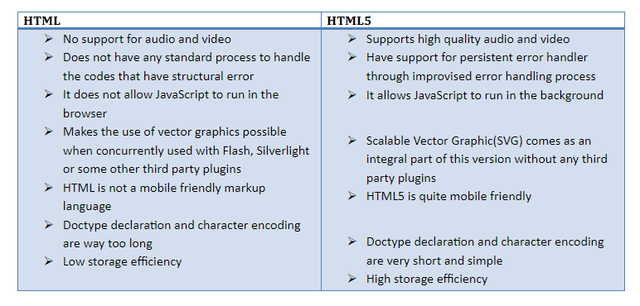](data:image/svg+xml,%3Csvg%20xmlns=)

**10.  How to create a table in HTML?**

HTML tables help web developers to set the data into rows and columns.

The <table> tag is there in the HTML table.  
Each table row can be defined with a <tr> tag.  
Each header can be defined with a <th> tag.   
Each data or the cell is defined with a <td> tag.  
If your text is in the  <th> elements then they will be bold and centered.  
If your text is in the <td> elements then they will be regular and left-aligned.

<table style="width:100%">

<tr>

<th>Firstname</th>

<th>Lastname</th>

<th>Hobbies</th>

</tr>

<tr>

<td>praveen</td>

<td>Kumar</td>

<td>Travelling</td>

</tr>

<tr>

<td>srikanth</td>

<td>sree</td>

<td>Reading books</td>

</tr>

</table>